Домашнее Задание №2

Определить законы изменения во времени токов и напряжений, указанных на схеме стрелками. Построить временные зависимости рассчитанных токов и напряжений. Определить постоянную времени цепи.

Единицы измерения: *e* [В], *i* [А], *R* [Ом], *L* [Гн], *C* [Ф].

Вариант 1.

|  |  |  |  |  |  |  |
| --- | --- | --- | --- | --- | --- | --- |
|  | *e* | *J* | *R* | *R1* | *L* | *C* |
| а | 20 | 1 | 1 | 20 | 0,05 | 5⋅10-4 |

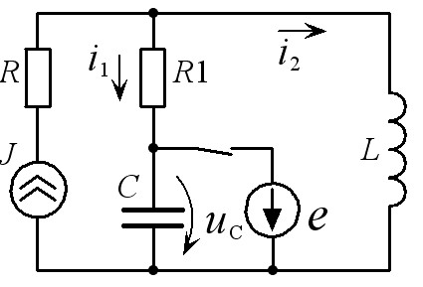

Вариант 2.

|  |  |  |  |  |  |
| --- | --- | --- | --- | --- | --- |
|  | *e* | *R* | *R1* | *L* | *C* |
| а | 100 | 10 | 10 | 10-2 | 10-4 |

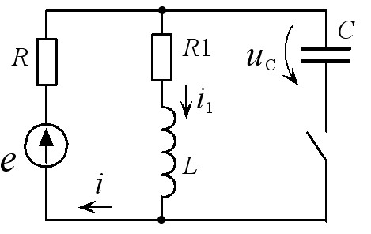

Вариант 3.

|  |  |  |  |  |  |
| --- | --- | --- | --- | --- | --- |
|  | *e* | *R* | *R1* | *L* | *C* |
| а | 100 | 200 | 200 | 0,01 | 6.25⋅10-6 |

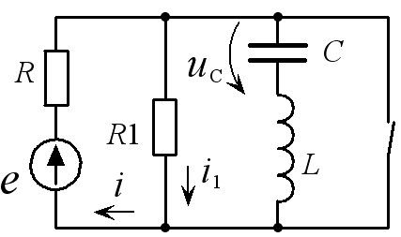

Вариант 4.

|  |  |  |  |  |  |
| --- | --- | --- | --- | --- | --- |
|  | *e* | *R* | *R1* | *L* | *C* |
| а | 100 | 25 | 25 | 0,5 | 2⋅10-4 |

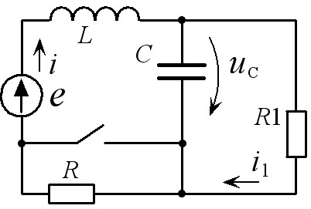

Вариант 5.

|  |  |  |  |  |  |  |
| --- | --- | --- | --- | --- | --- | --- |
|  | *J* | *e* | *R1* | *R2* | *L* | *C* |
| а | 5 | 50 | 10 | 50 | 0,1 | 10-3 |

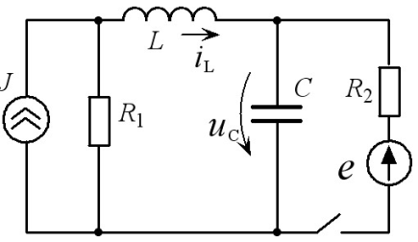

Вариант 6.

|  |  |  |  |  |  |  |
| --- | --- | --- | --- | --- | --- | --- |
|  | *E* | *R* | *R1* | *R2* | *L* | *C* |
| а | 200 | 10 | 30 | 10 | 10-2 | 10-4 |

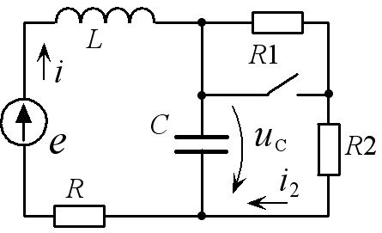

Вариант 7.

|  |  |  |  |  |  |  |
| --- | --- | --- | --- | --- | --- | --- |
|  | *e* | *J* | *R1* | *R2* | *L* | *C* |
| а | 200 | 2 | 50 | 150 | 0,25 | 10-4 |

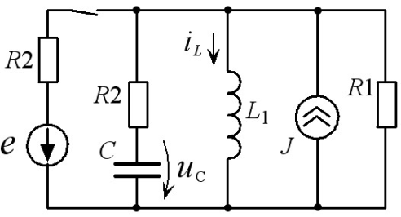

Вариант 8.

|  |  |  |  |  |
| --- | --- | --- | --- | --- |
|  | *e* | *R* | *L* | *C* |
| а | 40 | 10 | 10-2 | 10-4 |

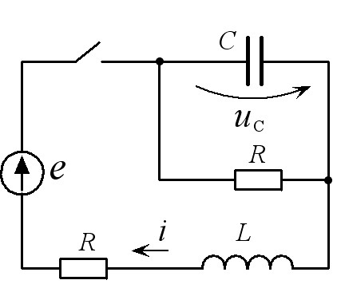

Вариант 9.

|  |  |  |  |  |  |  |
| --- | --- | --- | --- | --- | --- | --- |
|  | *e* | *J* | *R1* | *R2* | *L* | *C* |
| а | 200 | 5 | 10 | 15 | 0,1 | 2.5⋅10-4 |

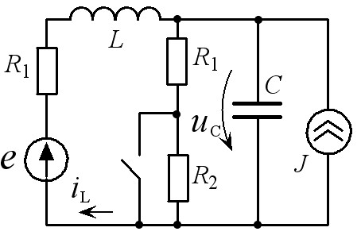

Вариант 10.

|  |  |  |  |  |  |  |
| --- | --- | --- | --- | --- | --- | --- |
|  | *e* | *J* | *R1* | *R2* | *L* | *C* |
| а | 200 | 2 | 200 | 100 | 10-2 | 10-6 |

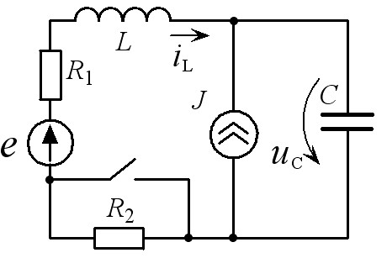

Вариант 11.

|  |  |  |  |  |  |  |
| --- | --- | --- | --- | --- | --- | --- |
|  | *e1* | *e2* | *R1* | *R2* | *L* | *C* |
| а | 100 | 50 | 10 | 10 | 0,1 | 10-3 |

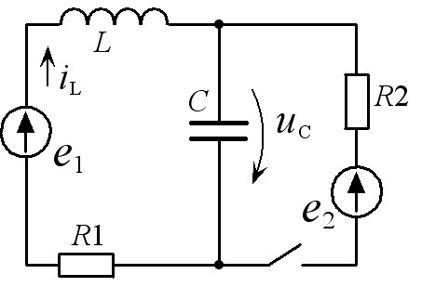

Вариант 12.

|  |  |  |  |  |  |  |
| --- | --- | --- | --- | --- | --- | --- |
|  | *J1* | *J2* | *R1* | *R* | *L* | *C* |
| а | 2 | 5 | 20 | 10 | 0,05 | 5⋅10-4 |

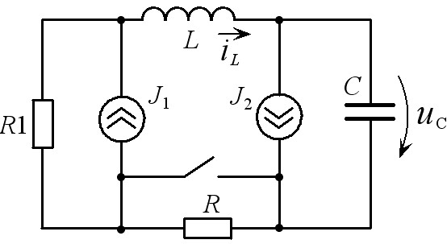

Вариант 13.

|  |  |  |  |  |  |  |
| --- | --- | --- | --- | --- | --- | --- |
|  | *e1* | *e2* | *R1* | *R2* | *L* | *C* |
| а | 200 | 100 | 25 | 100 | 0,05 | 5⋅10-4 |

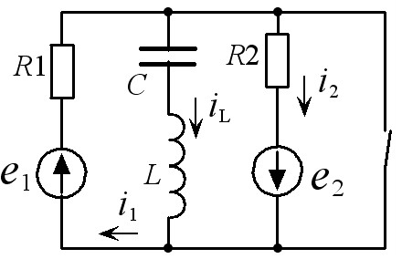

Вариант 14.

|  |  |  |  |  |  |  |
| --- | --- | --- | --- | --- | --- | --- |
|  | *e* | *J* | *R1* | *R2* | *L* | *C* |
| а | 200 | 2 | 50 | 150 | 0,25 | 10-4 |

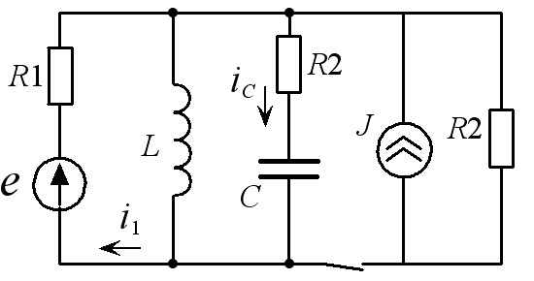

Вариант 15.

|  |  |  |  |  |  |  |
| --- | --- | --- | --- | --- | --- | --- |
|  | *e* | *J* | *R1* | *R2* | *L* | *C* |
| а | 200 | 2 | 100 | 150 | 0,25 | 10-4 |

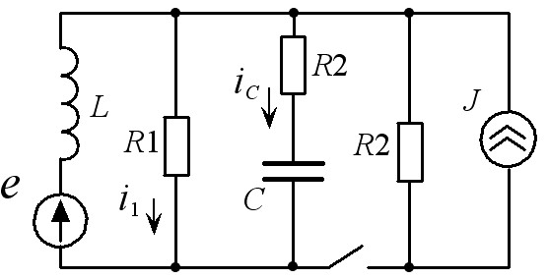

Вариант 16.

|  |  |  |  |  |  |  |
| --- | --- | --- | --- | --- | --- | --- |
|  | *e* | *J* | *R1* | *R2* | *L* | *C* |
| а | 100 | 2 | 50 | 150 | 0,25 | 10-4 |

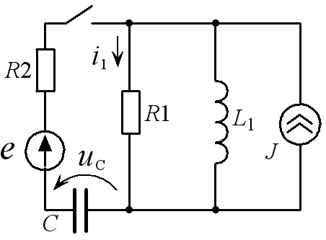

Вариант 17.

|  |  |  |  |  |  |  |
| --- | --- | --- | --- | --- | --- | --- |
|  | *e* | *J* | *R1* | *R2* | *L1* | *L2* |
| а | 150 | 5 | 7 | 9 | 7/40 | 0,1 |

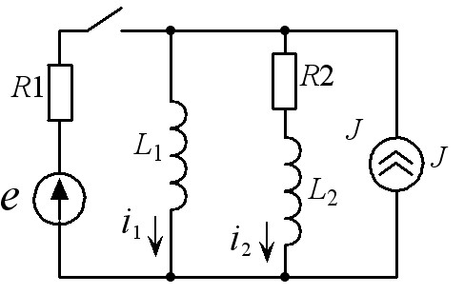

Вариант 18.

|  |  |  |  |  |  |
| --- | --- | --- | --- | --- | --- |
|  | *e* | *J* | *R* | *L* | *C* |
| а | 100 | 10 | 20 | 0,05 | 5⋅10-4 |

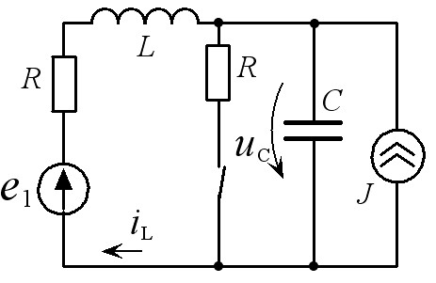

Вариант 19.

|  |  |  |  |  |  |  |  |
| --- | --- | --- | --- | --- | --- | --- | --- |
|  | *e1* | *e2* | *R1* | *R2* | *R3* | *L* | *C* |
| а | 100 | 200 | 10 | 10 | 10 | 0,1 | 10-3 |

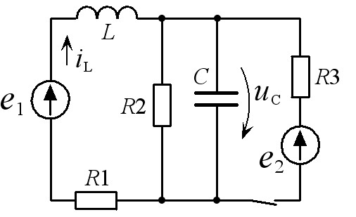

Вариант 20.

|  |  |  |  |  |  |  |
| --- | --- | --- | --- | --- | --- | --- |
|  | *e* | *J* | *R1* | *R2* | *L* | *C* |
| а | 200 | 10 | 10 | 10 | 0,1 | 10-3 |

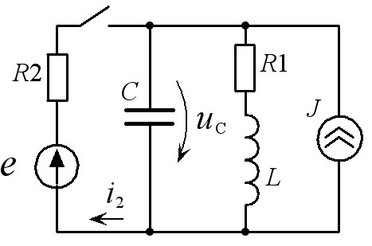

Вариант 21.

|  |  |  |  |  |  |  |
| --- | --- | --- | --- | --- | --- | --- |
|  | *e* | *J* | *R1* | *R2* | *L* | *C* |
| а | 200 | 5 | 20 | 10 | 0,05 | 5⋅10-4 |

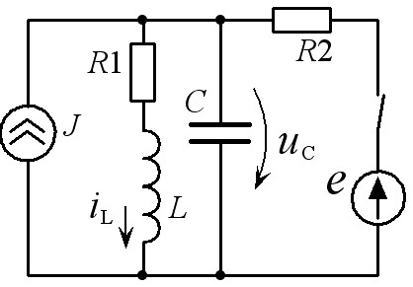

Вариант 22.

|  |  |  |  |  |  |  |
| --- | --- | --- | --- | --- | --- | --- |
|  | *e* | *J* | *R1* | *R2* | *L* | *C* |
| а | 100 | 5 | 10 | 10 | 0.1 | 10-3 |

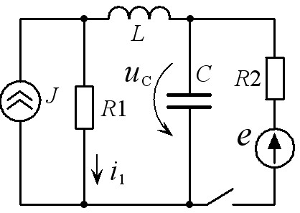

Вариант 23.

|  |  |  |  |  |  |
| --- | --- | --- | --- | --- | --- |
|  | *e* | *R1* | *R2* | *L* | *C* |
| а | 200 | 10 | 10 | 10-2 | 10-4 |

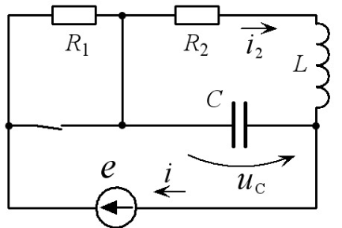

Вариант 24.

|  |  |  |  |  |  |
| --- | --- | --- | --- | --- | --- |
|  | *e* | *R* | *R1* | *L* | *C* |
| а | 40 | 10 | 10 | 6⋅10-3 | 10-5 |

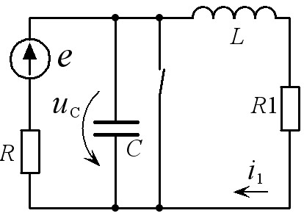

Вариант 25.

|  |  |  |  |  |  |  |
| --- | --- | --- | --- | --- | --- | --- |
|  | *e* | *J* | *R* | *R1* | *L* | *C* |
| а | 20 | 1 | 20 | 30 | 0,05 | 4⋅10-5 |

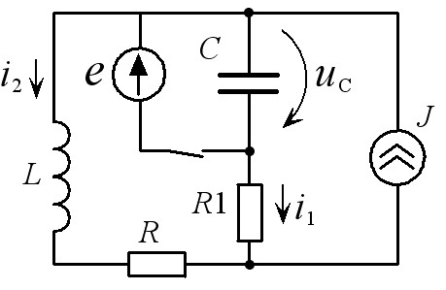

Вариант 26.

|  |  |  |  |  |  |  |
| --- | --- | --- | --- | --- | --- | --- |
|  | *e1* | *e2* | *R1* | *R2* | *L* | *C* |
| а | 200 | 100 | 25 | 100 | 0,05 | 5⋅10-4 |

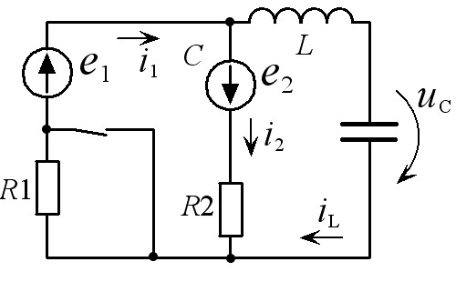

Вариант 27.

|  |  |  |  |  |  |
| --- | --- | --- | --- | --- | --- |
|  | *e* | *R* | *R1* | *L* | *C* |
| а | 200 | 200 | 200 | 10-2 | 10-6 |

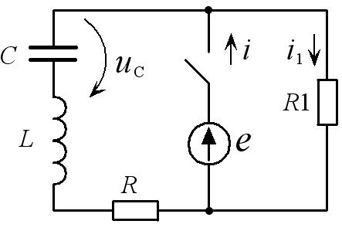

Вариант 28.

|  |  |  |  |  |
| --- | --- | --- | --- | --- |
|  | *e* | *R* | *L* | *C* |
| а | 100 | 100 | 10-3 | 10-7 |

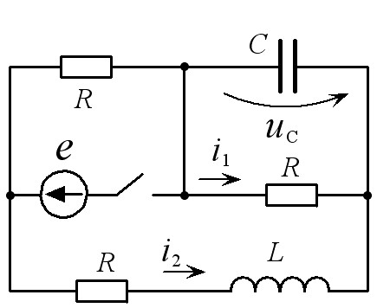

Вариант 29.

|  |  |  |  |  |  |  |
| --- | --- | --- | --- | --- | --- | --- |
|  | *e* | *J* | *R1* | *R2* | *L* | *C* |
| а | 200 | 10 | 20 | 10 | 0,05 | 5⋅10-4 |

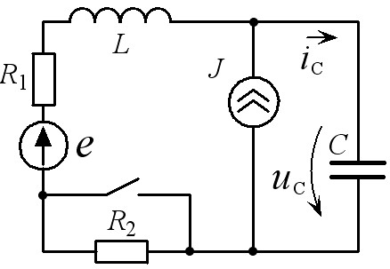

Вариант 30.

|  |  |  |  |  |  |  |  |
| --- | --- | --- | --- | --- | --- | --- | --- |
|  | *e* | *J* | *R1* | *R2* | *R3* | *L1* | *L2* |
| а | 50 | 10 | 6 | 6 | 8 | 0,1 | 0.133 |

