*Self-working paper made by _______________________________________________*

*1. Прочитайте слова и выражения, определите их русские эквиваленты.*

|  |  |  |
| --- | --- | --- |
|  | flood port | 1. площадь ватерлинии |
|  | air vent | 1. обтекатель рубки; ограждение рубки |
|  | forward dome | 1. запас плавучести |
|  | aft cone | 1. восстанавливающий / стабилизирующий момент |
|  | a sail | 1. выступающая часть корпуса подводной лодки |
|  | metacenter | 1. плавучесть |
|  | metacentric height | 1. открытый прочный корпус |
|  | transverse stability | 1. вентиляционное отверстие, воздушное отверстие; воздухозаборник |
|  | reserve of buoyancy (ROB) | 1. воздух высокого давления |
|  | a righting moment | 1. горизонтальный руль |
|  | waterplane area | 1. метацентр |
|  | an appendage | 1. конусообразная кормовая часть |
|  | floatation | 1. поперечная остойчивость |
|  | enclosed pressure hull | 1. эффективный (полезный) объем |
|  | exposed pressure hull | 1. шпигат |
|  | hydroplane | 1. объёмное водоизмещение |
|  | high pressure air | 1. закрытый прочный корпус |
|  | the effective volume | 1. метацентрическая высота |
|  | volume of effective buoyancy | 1. куполообразная носовая часть |
|  | volumetric displacement | 1. величина (объем) засчитываемой плавучести |

2. *Какова структура приведенных ниже предложений? Выделите их грамматические основы (подлежащее + сказуемое). Опишите форму сказуемого (время, залог).*

The most unique feature of submarine design stability is that unlike ships, submarine stability is studied at two conditions. _________________________________________________________

Sea water was taken into these tanks, and this added weight of the sea water increased the weight of the submarine, which allowed the submarine to dive. _____________________________

________________________________________________________________________________

The amount of ROB that needs to be incorporated in a design depends on the size of the submarine. _______________________________________________________________________

The metacentre (M) if above the centre of gravity, creates a righting moment that brings the submarine back to upright position. ___________________________________________________

________________________________________________________________________________

*3. Прочитайте текст, озаглавьте.*

1. _______________________________________________________________________

The most unique feature of submarine design stability is that unlike ships, submarine stability is studied at two conditions:

* Surfaced Stability (when part of the submarine is above the waterline), and
* 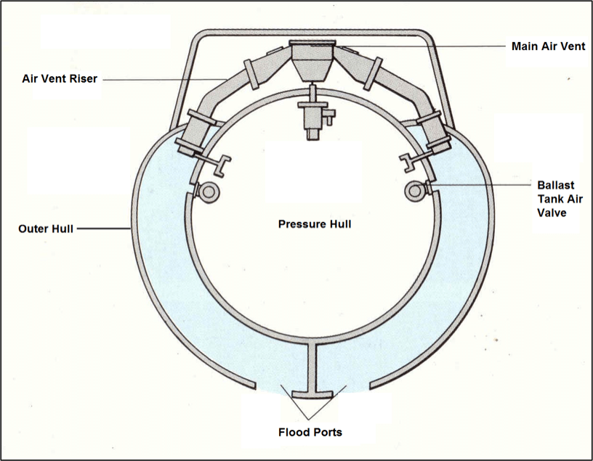Submerge Stability (when the submarine is completely submerged, and no part or appendages are above the waterline).

The fundamentals of floatation and Archimedes’ Principle are used to arrive at the equation of floatation of a submarine, that is, in either of submerged or surfaced condition, the weight of the submarine is equal to the buoyancy force acting on it. This also implies that for a surfaced submarine to submerge, the total weight of the submarine has to increase. It is only then that in submerged condition, the buoyancy on the volume of the submarine above the waterline (in surfaced condition) can be balanced with the additional weight.

*Figure 1: Transverse Section of Main Ballast Tank*

So how is weight added to the submarine? Do you remember Main Ballast Tanks (MBTs)? Sea water is taken into these tanks, and this added weight of the sea water increases the weight of the submarine, which allows the submarine to dive.

*4. Задайте специальный вопрос к тексту так, чтобы ответ на заданный вопрос передавал его основное содержание. Запишите ответ на заданный Вами вопрос.*

________________________________________________________________________________________________________________________________________________________________________________________________________________________________________________________________________________________________________________________________

5. *Закончите предложения:*

1. A submarine is a __________________________________________ that is designed to _______

__________________________________________________.

2. Submarine design can have a ______________ or _______________________ system that contains all the important systems and manpower.

3. The buoyancy is controlled on the submarine by ______________________________________ .

4. __________________________________ are employed to maintain the submarine’s equilibrium.

5. The sea water comes into the tanks through __________________________ and forces the air out.

6. The maximum number of decks that can be built inside the submarine depends on the _____________________________________.

7. _________________________________________ are used as auxiliary means to dive and resurface in waves and when it is necessary to provide quick diving or quick resurfacing.

*6. Выразите сомнение в данном утверждении, обоснуйте своё мнение, используя речевые клише (7-10 предложений, не обязательно использовать все предложенные клише):*

Double-hull submarines have less manoeuvrability, less stability and less survivability, than single-hull submarines.

|  |  |
| --- | --- |
| **Противоположная точка зрения (Contrasting point of view)** | |
| On the other hand… | С другой стороны… |
| There is another side to this. | Есть и другая сторона. |
| There are 2 ways of looking at this… | На это можно посмотреть с двух сторон. |
| There are different views of… | Существуют разные мнения насчет… |
| It would be a mistake to think that… | Было бы ошибкой (неправильно) думать, что… |
| **Прояснение ситуации, акцентирование внимания (Clearing up, emphasizing)** | |
| Nobody would want to deny the fact that… | Никто не станет отрицать тот факт, что… |
| And the thing that comes particularly strongly is… | И особенно привлекает внимание (выделяется) такая вещь, как… |
| One of the things that must be of concern (importance) to us is… | Во-первых, мы должны обратить внимание на… (Для нас имеет большое значение, во-первых…) |
| I’d like to remind you that… | Хотелось бы напомнить, что… |
| We have to bear in mind that… | Необходимо помнить, что… |
| One has to bear in mind… | Каждый должен помнить, что… |
| It must be admitted that… | Необходимо отметить, что… |
| But one mustn’t lose sight of the fact that… | Нельзя упускать из вида тот факт, что… |
| The other thing that we should keep in mind is… | Следующая вещь (следующий момент), о которой (-ом) необходимо помнить… |
| To go right to the heart of the problem I’d like to say that… | Переходя к сути проблемы, я хотел бы сказать, что… |
| Reservation should be made. | Необходимо сделать оговорку. |