LESSON 3-4. Introduction into Submarine Design
Vocabulary work
1. Прочитайте слова и выражения, отработайте их произношение, познакомьтесь с переводом на русский язык.

 | English combinations of words | Russian equivalents
 | self-propelled crafts | самоходные суда
 | a stipulated amount of time | ограниченное (заранее определенное) количество времени
 | the submarine design process | процесс проектирования подводной лодки
 | the accommodation spaces | жилые помещения
 | the pressure hull | прочный корпус
 | the outer hull | внешний (наружный) корпус
 | to withstand the hydrostatic pressure | выдерживать гидростатическое давление
 | the maximum operable depth | максимальная эксплуатационная глубина
 | cylindrical pressure hull | прочный корпус цилиндрической формы
 | pressure tight | герметичный
 | Main Ballast Tanks | цистерны главного балласта
 | exposed pressure hull | открытый прочный корпус
 | enclosed pressure hull | закрытый прочный корпус
 | waisted pressure hull | сужающийся прочный корпус
 | exposed pressure hull reduced at ends | открытый прочный корпус, суженный (уменьшенный) в хвостовой и носовой частях
 | submarine warfare | подводные боевые действия; ведение боевых действий подводными лодками
 | underwater rescue | спасательные работы под водой
 | underwater research | подводные исследования
 | resistance of appendages | сопротивление выступающих частей
 | control surface | плоскость управления (плоскость руля)
 | snorkelling | плавание на перископной глубине
 | the skin friction resistance | сопротивление поверхностного трения
 | viscous shear | сила вязкого сопротивления

2. Выделите в приведенных ниже словах приставки, суффиксы; укажите, от каких слов образованы приведенные ниже слова, укажите часть речи (1 – noun, 2 – adjective, 3 – adverb, 4 - verb) и переведите слова.
Например: oper-able (2, действующий, рабочий) ← oper-ate (действовать, работать)
underwater, description, confidential, useful, naval, arrangement, stability, available, acceptable, depth, compartmentalize, completely

3. Определите значения слов, выделенных в предложениях. Какую роль в предложении они выполняют: (1) выражение причинно-следственных отношений, (2) выражение отношений уступки, (3) выражение отношений сходства, подобия, (4) выражение отношений противопоставления, контраста, (5) выражение отношений последовательности?
This, though, is a very simple description of a very complex engineering product, which is used for a wide range of purposes such as underwater research, underwater rescue, and submarine warfare; the last one being the most widely used.
The latter can be attained only by proper matching of hull and propeller.
During their mission, modern submarines operate mainly below the water surface, therefore they have to be designed mainly for good performance in submerged condition.
Since there is no free surface at deep submergence, no wave making occurs and thus the wave resistance vanishes.
The skin friction resistance is due to the viscous shear of water flowing over the hull.
For a given volume, a sphere (L/D=1) has the smallest surface and thus the smallest skin friction resistance.
However, we want to optimise power requirements.
Therefore propulsive aspects and the second resistance component have to be considered as well.
In consequence there is an optimum, albeit a very flat one.
Grammar work
4. Определите часть речи и функции форм слов, заканчивающихся на -ed, в предложениях; переведите.
Например: It’s rather useful to study … the systems us-ed (причастие прошедшего времени (Past Participle / Participle II), определение; используемые) in a submarine.
It is call-ed (образует форму Passive Voice, сказуемое; называется) the pressure hull because it is design-ed (образует форму Passive Voice, сказуемое; проектируется) to withstand the hydrostatic pressure.
1) Submarines are underwater self-propelled crafts that are designed and built to perform underwater operations for a stipulated amount of time.
2) Hull system houses all the necessary systems and manpower required for completion of their mission.
3) This, though, is a very simple description of a very complex engineering product, which is used for a wide range of purposes.
4) The submarine design process followed by all navies is confidential.
5) Once we have looked into these, it would be easy for us to touch on the submarine design process.
5. Найдите в тексте соответствия следующим словам и выражениям:
в течение установленного периода времени (1 абзац), конструктивное исполнение и устройство (2 абзац), соответствовать функциональному назначению (3 абзац), сопротивление корпуса должно быть сведено к минимуму (4 абзац), при глубоком погружении нет свободной поверхности (5 абзац), уменьшение смачиваемой поверхности (7 абзац), результирующее напряжение сдвига (8 абзац), противоположные требования (10 абзац).

6. Прочитайте и переведите текст. В пронумерованных предложениях найдите и выделите грамматическую основу (грамматические основы) (подлежащее + сказуемое), определите залог и время личной формы глагола.

Introduction to Submarine Design

1) Submarines are underwater self-propelled crafts that are designed and built to perform underwater operations for a stipulated amount of time. Submarine design consists of a single or double hull system that houses all the necessary systems and manpower required for completion of their mission. This, though, is a very simple description of a very complex engineering product, which is used for a wide range of purposes such as underwater research, underwater rescue, and submarine warfare; the last one being the most widely used.
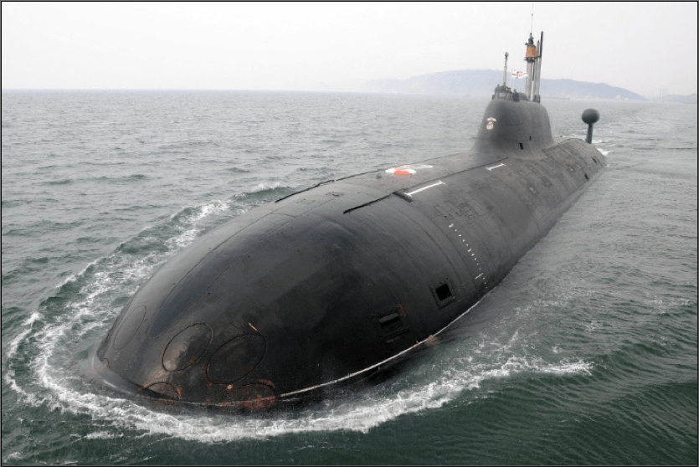
It’s important to notice that though the submarine design process followed by all navies is confidential, and different from each other, the basics still remain the same. It’s rather useful to study the design of naval submarines, to familiarize ourselves with the functionalities of a submarine, its parts, general arrangement, structural design and arrangement, stability of a submarine, the systems used in a submarine, etc. Once we have looked into these, it would be easy for us to touch on the submarine design process.
The primary submarine design objectives are:
- The submarine should cater to the functional purpose of the customer.
- The design should be capable of being constructed with the available resources.
- The cost of the project should be acceptable by the customer.
Figure 1: Indian Navy’s Akula Class Attack Submarine INS Chakra (Surfaced Condition)
One of the most important characteristics of a submarine is the speed that can be achieved by a given power output developed by the propulsion plant. The necessary power has to be as low as possible, i.e. the resistance of the hull including appendages and control surfaces should be minimised and the propulsive efficiency maximised. The latter can be attained only by proper matching of hull and propeller. The optimisation of the resistance and propulsive efficiency are essential because of their influence on cruising range and maximum speed.
2) During their mission, modern submarines operate mainly below the water surface, therefore they have to be designed mainly for good performance in submerged condition. Since there is no free surface at deep submergence, no wave making occurs and thus the wave resistance vanishes. For snorkelling at low to moderate speeds, the wave resistance is also negligibly small.
It is customary to decompose the resistance of the naked hull of a deeply submerged submarine into two components:
- Friction resistance
The skin friction resistance (flat plate) is in the order of 60% to 70% of the total resistance for submarines. The skin friction resistance is due to the viscous shear of water flowing over the hull. It is essentially related to the exposed surface area and the velocities over the hull. Therefore reducing the wetted surface (for a given speed) is desirable to reduce the resistance.
- Form resistance (or viscous pressure resistance)
The form of the submarine induces a local flow field with velocities sometimes higher and sometimes lower than the average velocity. The average of the resulting shear stresses is then higher. The form resistance can be minimised by having slowly varying sections along the body. A needle-shape would be good in respect of form resistance.
- Wave resistance
A ship at or near the free surface creates a typical wave system which contributes to the total resistance. Wave resistance disappears for the deeply submerged submarine.
Optimising for either only skin friction resistance or form resistance thus leads to opposing requirements. In consequence there is an optimum, albeit a very flat one. 3) This optimum is again shifted if also appendages are considered.
Hulls of a Submarine
Outer Hull and Pressure Hull
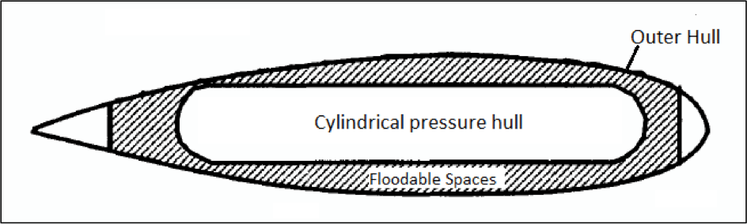
Most designs of submarines have two hulls. The hull that houses all the accommodation spaces, weapons, weapon control systems, communications and control room, battery banks, main and auxiliary machinery, is the pressure hull. It is called the pressure hull because it is designed to withstand the hydrostatic pressure at the maximum operable depth of the submarine.
Figure 2: Cylindrical Pressure hull and Outer hull of a submarine.
4) The pressure hull is housed inside the outer hull, which is not pressure tight. Why? Because, in submerged condition, the spaces between the outer and the inner hull always remain flooded with sea water. Hence, the hydrostatic pressure on the outer hull is negligible.
Main Ballast Tanks (MBTs)
Now, the “floodable” spaces are compartmentalized into tanks, which in submarine terminology, are called Main Ballast Tanks. 5) The distribution of main ballast tanks in a submarine depends on the shape and interaction of the outer and pressure hull. We will understand the working of MBTs after we deal with the process of submerging a submarine, and submarine stability. 6) Some designs have MBTs only at the forward and aft regions, and the rest of the pressure hull is flushed with the outer hull. Other designs have completely different outer and pressure hull, with space for ballast between them. Some arrangements of MBTs are shown in the figures below.
Figure 3: Exposed Pressure Hull (MBTs at forward and aft).

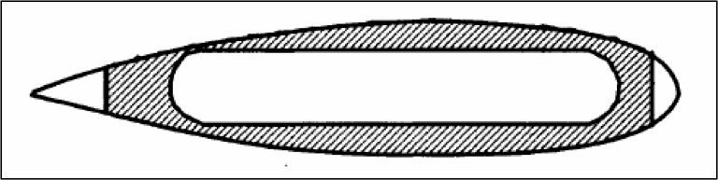
Figure 4: Enclosed Cylindrical Pressure Hull (MBTs throughout the length).

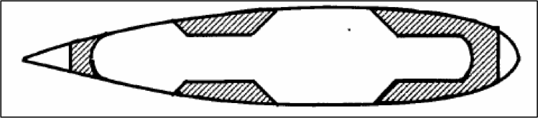
Figure 5: Waisted Pressure Hull (MBTs at certain parts of the length).

Figure 6: Exposed pressure hull reduced at ends (MBTs at forward an aft).

Self-studying
Измените время и залог глаголов в предложениях (напишите не менее трех новых форм).
Submarines are designed and built to perform underwater operations.
__________________________________________________________________________________
_________________________________________________________________________________________
_________________________________________________________________________________________
Submarine design consists of a single or double hull system.
__________________________________________________________________________________
_________________________________________________________________________________________
_________________________________________________________________________________________
A very complex engineering product is used for a wide range of purposes.
__________________________________________________________________________________
_________________________________________________________________________________________
_________________________________________________________________________________________
The basics of the submarine design process still remain the same in all navies.
__________________________________________________________________________________
_________________________________________________________________________________________
_________________________________________________________________________________________
The wave resistance is also negligibly small.
__________________________________________________________________________________
_________________________________________________________________________________________
_________________________________________________________________________________________
The pressure hull houses all the accommodation spaces.
__________________________________________________________________________________
_________________________________________________________________________________________
_________________________________________________________________________________________
The pressure hull is adapted to withstand the hydrostatic pressure.
__________________________________________________________________________________
_________________________________________________________________________________________
_________________________________________________________________________________________

